
North Mundham Primary School
Safeguarding and Child Protection Policy



Approved by: | To be approved | Valid from Date: 1st September 2025
Next review due by: | September 2026

Policy based on West Sussex

Child Protection Policy
Procedure and Guidance



Schools and Education

Published September 2025
Review due September 2026

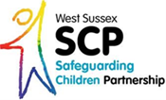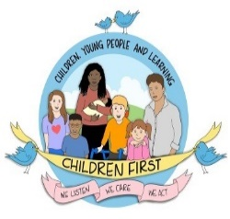

Table of Contents

North Mundham Primary School Child Protection and Safeguarding Policy 3
Roles and responsibilities within North Mundham school 7
North Mundham Primary School Child Protection Procedures 10
Annex 1 - Flowchart for child protection procedures 12
Annex 2 - Example Recording form 13
Annex 3 - Skin map 14
Annex 4 - Dealing with disclosures 16
Annex 5 - Allegations against adults who work with children 19
Annex 6 - Sexual violence and sexual harassment between children in schools and colleges 22
Annex 7 - Online Safety 26
Annex 8 - Whistleblowing 27
Annex 9 - Briefing sheet for temporary / supply staff 28
Annex 10 - What is child abuse? 29
Annex 11 - Useful contacts 36
Annex 12 - Table of changes 2025 37

North Mundham Primary School Child Protection Policy
Policy Statement
‘Safeguarding and promoting the welfare of children is everyone’s responsibility. Everyone who comes into contact with children and their families has a role to play. In order to fulfil this responsibility effectively, all practitioners should make sure their approach is child centred. This means that they should consider, at all times, what is in the best interests of the child.’
Keeping Children Safe in Education – Statutory guidance for schools colleges (KCSiE)

We recognise our moral and statutory responsibility to safeguard and promote the welfare of all children.
We make every effort to provide a safe and welcoming environment underpinned by a culture of openness where both children and adults feel secure, able to talk and believe that they are being listened to.
We maintain an attitude of “it could happen here” where safeguarding is concerned.
The purpose of this policy is to provide staff, volunteers and governors with the framework they need in order to keep children safe and secure in our school, and to inform parents and guardians how we will safeguard their children whilst they are in our care.
Specific guidance is available to staff within the procedure documents.

Definitions

Child protection is an aspect of safeguarding but is focused on how we respond to children who have been significantly harmed or are at risk of significant harm.

The term staff applies to all those working for or on behalf of the school, full time or part time, in either a paid or voluntary capacity. This also includes parents and governors.

Child refers to all young people who have not yet reached their 18th birthday. On the whole, this will apply to pupils of our school; however, the policy will extend to visiting children and students from other establishments

Parent refers to birth parents and other adults in a parenting role for example adoptive parents, step-parents, guardians and foster carers.

Abuse could mean neglect, physical, emotional or sexual abuse or any combination of these, as well as children witnessing domestic abuse. Parents, carers and other people can harm children either by direct acts and / or failure to provide proper care. Explanations of these are given within the procedure document.
Aims

- To provide staff with the framework to promote and safeguard the wellbeing of children and in so doing ensure they meet their statutory responsibilities.
- To ensure consistent good practice across the school.
- To demonstrate our commitment to protecting children.

Principles and Values

- Children have a right to feel secure and cannot learn effectively unless they do so.
- All children have a right to be protected from harm.
- All staff have a key role in prevention of harm and an equal responsibility to act on any suspicion or disclosure that may indicate a child is at risk of harm, either in the school or in the community, whilst taking into account any contextual safeguarding.
- We acknowledge that is essential that we work in partnership with other agencies that protect children and reduce risk and so we will engage in partnership working throughout the child protection process to safeguard children.
- Whilst the school will work openly with parents as far as possible, it reserves the right to contact Children’s Social Care or the police, without notifying parents if this is believed to be in the child’s best interests.
- All adults working within the school should maintain professional curiosity if they are concerned about a child.

Leadership and Management

We have established clear lines of accountability, training and advice to support the process of child protection and individual staff within that process.
In this school, any individual can contact the Designated Safeguarding Lead (DSL) or their Deputy (DDSL) if they have concerns about a child or young person.
The DSL is Zoe Gordon and the DDSLs are Linds Robins and Laura Finch. There is a nominated safeguarding governor, Chris Jack, who will take leadership responsibility for safeguarding. The Chair of Governors Chris Jack will receive reports of allegations against the headteacher and act on the behalf of the governing body.

As an employer we follow safer recruitment guidance as set out in KCSiE 2025 including informing shortlisted candidates that online searches will be carried out.

Training

All staff in our school are expected to be aware of the signs and symptoms of abuse and must be able to respond appropriately. Training is provided as required annually at the start of the year and updates, briefings are given throughout the year. Separate training is provided to all new staff on appointment by the DSL. The DSL will attend training at least every other year to enable them to fulfil their role.
Any update in national or local guidance will be shared with all staff in briefings and then captured in the next whole school training. This policy will be updated during the year to reflect any changes brought about by new guidance.
Governor training is provided as required by KCSiE 2025 in Full Governing Body meeting (usually in March).

Referral

Following any concerns raised, the DSL will assess the information and consider if significant harm has happened or there is a risk that it may happen. If the evidence suggests the threshold of significant harm, or risk of significant harm has been reached, or if it is not clear if the threshold is met, the DSL will contact Children’s Social Care and, if appropriate, the police. If the DSL or DDSL is not available or there are immediate concerns, the staff member will refer directly to Children’s Social Care and the police if appropriate. We will use the guidance from NSPCC to determine when to contact the police.

Generally, the DSL will inform the parents prior to making a referral. However, there are situations where this may not be possible or appropriate, particularly when informing parents, may place the child at further risk
N.B. The exception to this process will be in those cases of known FGM where there is a mandatory requirement for the teacher to report directly to the police. The DSL should also be made aware.

Confidentiality

- We maintain that all matters relating to child protection are to be treated as confidential and only shared as per the ‘Information Sharing Advice for Practitioners’ (DfE 2024) guidance
- There is a lawful basis for child protection concerns to be shared with agencies who have a statutory duty for child protection.
- Information will be shared with individuals within the school who ‘need to know’.
- All staff are aware that they cannot promise a child to keep a disclosure confidential.

As a school we will educate pupils to recognise when they are at risk and how to get help when they need it through:

- The content of the curriculum will be tailored to the specific needs and vulnerabilities of individual children, including children who are victims of abuse, and children with SEND
- A school ethos which helps children to feel safe and able to talk freely about their concerns, believing that they will be listened to and valued.
- Every child having access to a ‘trusted adult’ in the school.
- Children will be taught about how to keep themselves and others safe when on-line through our Jigsaw PSE programme as well as the computing curriculum
- Assemblies based on NSPCC ‘Speak out’ campaign and other elements of our safeguarding curriculum.

Dealing with concerns and allegations against staff

If a concern is raised about the practice or behaviour of a member of staff, this information will be recorded and passed to the headteacher Zoe Gordon. The headteacher will make an assessment to determine if the matter is a ‘low level concern’ or an ‘allegation’. The Local Authority Designated Officer (LADO) will be contacted for all allegations and the relevant guidance will be followed. If the headteacher needs advice or guidance they will contact the LADO. If the allegation is against the headteacher, the person receiving the allegation will contact the LADO or Chair of Governors directly. (Annex 5)

Dealing with children abusing children
If a concern is raised that a child under 18 is abusing another child under 18, the ‘Child on Child Abuse’ guidance will be followed (Annex 6)

Legal context

Section 175 of the education act 2002; the Education (Independent School Standards) Regulations 2014; the Non-Maintained Special Schools (England) Regulations
Children Act 2004 & 1989

Guidance
West Sussex Safeguarding Children Partnership protocols and guidance and their procedures
Working Together to Safeguard Children (2023)
Keeping children safe in education - GOV.UK (www.gov.uk)
FGM Act 2003 Mandatory Reporting Guidance (2016)

Policy review

As a school, we review this policy at least annually in line with DfE, WSSCP and WSCC requirements and other relevant statutory guidance.

Date approved by governing body: 11th November 2025

Date reviewed by governing body: November 2026

Roles and responsibilities within North Mundham Primary School

Staff responsibilities

All staff have a key role to play in identifying concerns early and in providing help for children. To achieve this, they will:

- Establish and maintain an environment where children feel secure, are encouraged to talk and are listened to.
- Ensure children know that there are adults in the school who they can approach if they are worried or have concerns.
- Plan opportunities within the curriculum for children to develop skills they need to recognise, assess and manage risk appropriately and keep themselves safe.
- Attend training in order to be aware of and be alert to the signs of abuse.
- Maintain an attitude of “it could happen here” with regards to safeguarding.
- Be aware that mental health problems can, in some cases, be an indicator that a child has suffered or is at risk of suffering abuse, neglect or exploitation.
- Recognise that abuse, neglect, or other adverse childhood experiences, can have an impact on the mental health, behaviour and education of children.
- Record their concerns if they are worried that a child is being abused and report these to the DSL as soon as practicable that day. If the DSL is not contactable immediately a DDSL should be informed.
- Be prepared to refer directly to social care, and the police if appropriate, if there is a risk of significant harm and the DSL or DDSL is not available.
- Follow the allegations procedures (Annex 5) if the disclosure is an allegation against a member of staff.
- Follow the procedures set out by the WSSCP and take account of guidance issued by the DfE.
- Support pupils in line with their child protection plan.
- Treat information with confidentiality but never promise to “keep a secret”.
- Notify the DSL or DDSL of any child on a child protection plan or child in need plan who has unexplained absence.
- Have an understanding of ‘Early Help’ and be prepared to identify and support children who may benefit from this intervention.
- Liaise with other agencies that support pupils and provide early help.
- Ensure they know who the DSL and DDSL are and know how to contact them.
- Have an awareness of the Child Protection Policy, the Behaviour Policy, the Staff Behaviour Policy (or Code of Conduct), child on child abuse procedures, the safeguarding response for children who go missing or are absent from education and the role of the DSL.

Senior Management Team responsibilities:

- Contribute to inter-agency working in line with ‘Working Together to Safeguard Children 2023 guidance’
- Provide a co-ordinated offer of early help when additional needs of children are identified
- Ensure staff are alert to the various factors that can increase the need for early help (para 18 KCSiE 2024)
- Working with Children’s Social Care, support their assessment and planning processes including the school’s attendance at conference and core group meetings.
- Carry out tasks delegated by the governing body such as training of staff, safer recruitment and maintaining a single central register.
- Provide support and advice on all matters pertaining to safeguarding and child protection to all staff regardless of their position within the school.
- Treat any information shared by staff or pupils with respect and follow agreed policies and procedures.
- Ensure that allegations or concerns against staff are dealt with in accordance with guidance from Department for Education (DfE) and the West Sussex Safeguarding Children Partnership (WSSCP) procedures.
- Determine if a concern about a member of staff is a ‘low level concern’ or an allegation

Governing body responsibilities

- Ensure the school has effective safeguarding policies and procedures including a Child Protection Policy, a Staff Behaviour Policy or Code of Conduct, a Behaviour Policy and a response to children who go missing from education.
- Ensure WSSCP is informed in line with local requirements about the discharge of duties via the annual safeguarding self assessment.
- Recruitment, selection and induction follows safer recruitment practice, including all appropriate checks.
- Allegations against staff are dealt with by the headteacher. Allegations against the headteacher are dealt with by the Chair of Governors.
- A member of the Senior Leadership Team is appointed as Designated Safeguarding Lead (DSL) and has this recorded in their job description.
- Staff have been trained appropriately and this is updated in line with guidance
- Any safeguarding deficiencies or weaknesses are remedied without delay
- A nominated governor for safeguarding is identified.

DSL responsibilities (to be read in conjunction with DSL role description in KCSiE)
In this school the DSL is Zoe Gordon
The Deputy DSL are Linds Robins and Laura Finch

In addition to the role of all staff and the senior management team, the DSL will

- Refer cases to social care, and the police where appropriate, in a timely manner avoiding any delay that could place the child at more risk.
- Assist the Governing Body in fulfilling their safeguarding responsibilities set out in legislation and statutory guidance.
- Attend appropriate training and demonstrate evidence of continuing professional development to carry out the role.
- Ensure every member of staff knows who the DSL and the Deputy are, have an awareness of the DSL role and know how to contact them.
- Ensure all staff and volunteers understand their responsibilities in being alert to the signs of abuse and their responsibility for referring any concerns about a child to the DSL and concerns about an adult to the headteacher.
- Ensure that those staff that need to know, are aware of those children who have experienced, or are experiencing abuse in order to promote their educational outcomes and provide the appropriate support.
- Ensure whole school training occurs regularly with at least annual updates so that staff and volunteers can fulfil their responsibilities knowledgeably.
- Ensure any members of staff joining the school outside of the agreed training schedule receive induction training prior to the commencement of their duties.
- Keep records of child protection concerns securely and separate from the main pupil file and use these records to support the assessment and likelihood of risk.
- Ensure that safeguarding records are transferred accordingly (separate from pupil files) and in a timely fashion when a child transfers school, including in-year transfers.
- Ensure that where a pupil transfers school and is on a child protection plan or is a child looked after, their information is passed to the new school immediately and that the child’s social worker is informed. Consideration is given to a transition meeting prior to moving if the case is complex or on-going.
- Be aware of the training opportunities and briefings provided by WSSCP to ensure staff are aware of the latest local guidance on safeguarding.
- Develop, implement and review procedures in the school that enable the identification and reporting of all cases, or suspected cases, of abuse.
- Meet any other expectations set out for DSLs in KCSiE 2025

North Mundham Primary School Child Protection Procedures

Overview

The following procedures apply to all staff working in the school and will be covered by training to enable staff to understand their role and responsibility.
The aim of our procedures is to provide a robust framework which enables staff to take appropriate action when they are concerned that a child is being harmed or is at risk of harm.

The prime concern at all stages must be for the interests and safety of the child. Where there is a conflict of interest between the child and an adult, the interests of the child must be paramount.

All staff are aware that very young children, those with disabilities, special needs, certain medical conditions or with language deficit/English as a second language may have more difficulty in communicating concerns or feelings. They may be more likely to communicate concerns with behaviours rather than words. Additionally, staff will question the cause of knocks and bumps in children who have limited mobility, which will include children (for example younger siblings) visiting the site in addition to pupils.

If a member of staff suspects abuse, spots signs or indicators of abuse, or they have a disclosure of abuse made to them they must:

- Make an initial record of the information

- Report it to the DSL immediately

- The DSL will consider if there is a requirement for immediate medical intervention. Urgent medical attention should not be delayed if the DSL is not immediately available

- Make an accurate record (which may be used in any subsequent judicial proceedings) as soon as possible and within 24 hours of the occurrence. Include everything that has happened, including details of:

- Dates and times of observations
- Dates and times of any discussions in which they were involved
- Any injuries
- Explanations given by the child / adult
- What action was taken
- Any actual words or phrases used by the child

The records must be signed and dated by the author with an equivalent procedure in place for electronic based records- we use Bromcom for this process.

- In the absence of the DSL or their Deputy, be prepared to refer directly to Children’s Social Care (and the police if appropriate) if there is the potential for immediate, significant harm.

Following a report of concerns the DSL must:

- Decide whether or not there are sufficient grounds for suspecting significant harm, in which case a referral must be made to Children’s Social Care and the police if it is in keeping with the National Police Chiefs Council “When to call the Police” guidance. The rationale for this decision should be recorded by the DSL. DSLs will also use the West Sussex neglect matrix and the threshold document to make informed decisions about the level of support required.
- Normally the school should try to discuss any concerns about a child’s welfare with the family and where possible seek their agreement before making a referral to Children’s Social Care. However, in accordance with DfE guidance, this should only be done when it will not place the child at increased risk or could have an impact on a police investigation. Where there are doubts or reservations about involving the child’s family, the DSL should clarify with Children’s Social Care or the police whether the parents should be told about the referral and, if so, when and by whom. This is important in cases where the police may need to conduct a criminal investigation. The child’s views should also be considered when appropriate.

- If there are grounds to suspect a child is suffering, or is likely to suffer, significant harm the DSL (or Deputy) must contact Children’s Social Care via Request support or raise a concern about a child - West Sussex County Council making a clear statement of:
  - the known facts
  - any suspicions or allegations
  - whether or not there has been any contact with the child’s family.

If there is indication that the child is suffering significant harm, a call will also be made to Integrated Front Door on 01403 229900

- If a child is in immediate danger and urgent protective action is required, the police must be called. The DSL must then notify Children’s Social Care of the occurrence and what action has been taken.

- When a pupil needs urgent medical attention and there is suspicion of parental abuse causing the medical need, the DSL or their Deputy should take the child to the nearest hospital with an accident and emergency facility and inform Children’s Social Care. Advice should be sought from Children’s Social Care about informing the parents, remembering that parents should normally be informed that a child requires urgent hospital attention.

- If there is not a risk of significant harm, the DSL will either actively monitor the situation or consider the Early Help process.

- In cases of allegations against staff or low level concerns, the WSSCP procedure or the school Low Level Concerns (LLC) procedure will be followed.

Annex 1 - Flowchart for child protection procedures

DSL – Designated Safeguarding Lead
Child
MASH – Multi Agency Safeguarding Hub
IFD – Integrated Front Door
CP – Child protection
LLC – Low Level Concern

Allegation against adult who works with children
Disclosure or allegation of sexual abuse
DSL
STAFF
Keep accurate records
and any original notes
Serious incident or recurrent episodes or inconsistent explanations

Consistent explanation or minor accident
Give reassurance, avoid leading questions and do not promise confidentiality

Physical injury, neglect or emotional abuse
Record the date, time, observations, what was said and who was present. Use a skin map to record visible injuries. NB. This is recorded by the first person the child speaks to as soon as possible after the event and within 24 hours after the event
In an emergency call for medical assistance
Inform the headteacher, unless allegation is against the headteacher, when the Chair of Governors (CoG) is informed.

)

Refer to the DSL as soon as practical on the same day as the concern is raised.
If the DSL is not available, contact the Deputy DSL…name
or refer directly to IFD
The DSL will make a judgement about the situation and either:
Work with the family through the early help process
Make a referral to children’s social care using the inter-agency referral form. If the child is at risk of harm, DSL will also call01403 229900. In cases of immediate danger, the police will be called.
Monitor the situation
All allegations go to the LADO via the portal Online Portal If the CoG is not available, for headteacher allegations, the LADO should be informed directly the same day. If LLC, school procedures to be followed
- DSL to inform those that need to know in the school, including the headteacher
- Upload report to Bromcom
- Receive feedback from MASH and work with the social worker if the case is allocated for assessment.
IFD will refer to MASH if it is felt to be CP. MASH will make the judgement and communicate with the school

* In the cases of known FGM, the teacher who was made aware will also make contact with the police

Annex 2 - Example Recording form
Remove if you do not use paper records or have different forms

Child’s name:
Date and time:
Name and role of person raising concern:

Details of concern (where? when? what? who? behaviours? Use child’s words)

Actions taken

Date | Person taking action | Action taken | Outcome of action

Name: Designation:

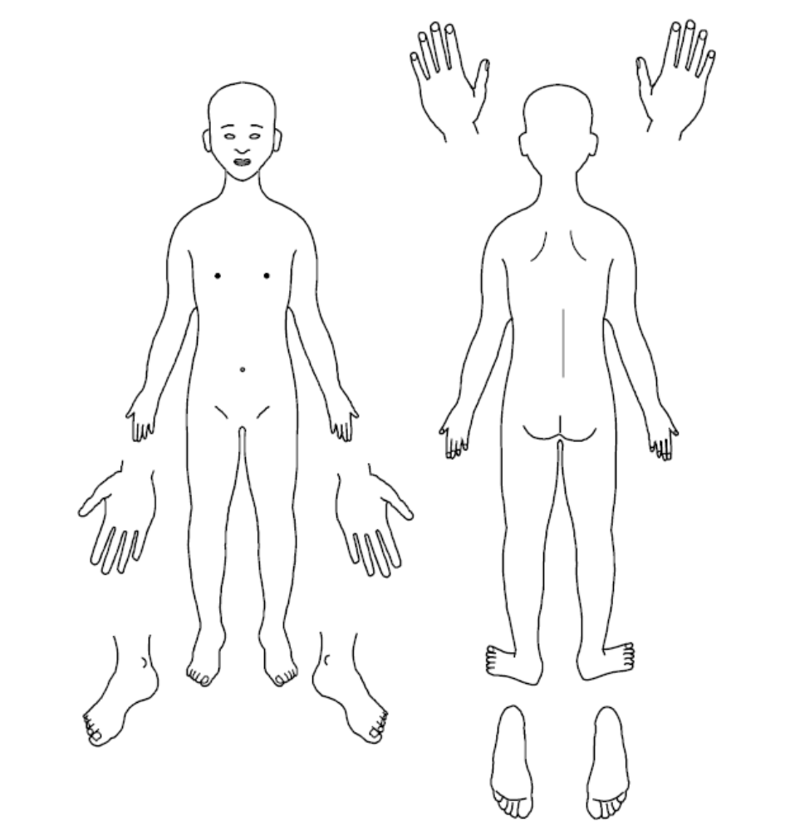
Annex 3 - Skin map

Name of Child: _______________________________________________________

Date of birth: _________________________ Date of recording: _________________

Name of person completing: ____________________________________________________

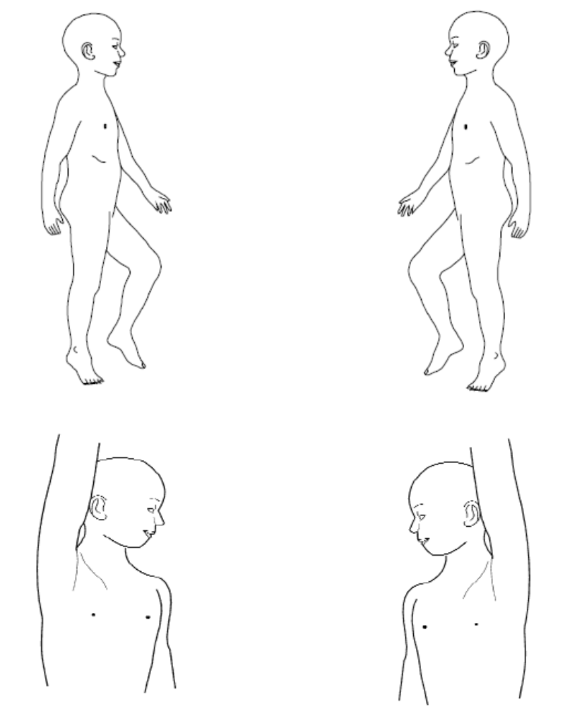

Any additional information:

Annex 4 - Dealing with disclosures

All staff should
A members of staff who are approached by a child should maintain a positive attitude and try to reassure them. They should not promise complete confidentiality and should explain that they may need to pass information to other professionals to help keep the child or other children safe. The degree of confidentiality should always be governed by the need to protect the child.
Additional consideration needs to be given to children with communication difficulties and for those whose preferred language is not English. It is important to communicate with them in a way that is appropriate to their age, understanding and preferred communication method.
All staff should know who the DSL is and who to approach if the DSL is unavailable. Ultimately, all staff have the right to make a referral to the police or social care directly and should do this if, for whatever reason, there are difficulties following the agreed protocol, e.g. they are the only adult on the school premises at the time and have concerns about sending a child home.
Guiding principles, the Three R’s
Recognise
- Listen to what is being said, without displaying shock or disbelief
- Accept what is said and take it seriously
- Make a note of what has been said as soon as practicable
- Reassure the pupil, but only so far as is honest and reliable
- Don’t make promises you may not be able to keep e.g. ‘I’ll stay
with you’ or ‘everything will be alright now’ or ‘I’ll keep this confidential’
- Do reassure e.g. you could say: ‘I am listening to you’, ‘I am glad you came to me’, ‘I am sorry this has happened’, ‘We are going to do something together to get help’

Respond
- Respond to the pupil only as far as is necessary for you to establish whether you need to refer this matter, but do not interrogate for full details
- Do not ask ‘leading’ questions i.e. ‘did he touch your private parts?’ or ‘did she hurt you?’ Such questions may invalidate your evidence (and the child’s) in any later court proceedings
- Do not ask the child why something has happened
- Do not criticise the alleged perpetrator; the pupil may care about them, and reconciliation may be possible
- Do not ask the pupil to repeat it all for another member of staff. Explain what you have to do next and to whom you need to talk. Reassure the pupil that it will be a senior member of staff in confidence.

Report
- Share concerns with the DSL as soon as possible
- If you are not able to contact your DSL or the Deputy, and the child is at risk of immediate harm, contact the children’s services social care department directly.
- If possible, make some very brief notes at the time, and write them up as soon as possible
- Keep your original notes on file
- Record the date, time, place, persons present and noticeable nonverbal behaviour, and the words used by the child. If the child uses sexual ‘pet’ words, record the actual words used, rather than translating them into ‘proper’ words
- Complete a body map to indicate the position of any noticeable bruising or marks
- Record facts and observable things, rather than your ‘interpretations’ or ‘assumptions’.
- Support the child: listen, reassure, and be available
- Complete confidentiality is essential. Share your knowledge only with appropriate professional colleagues
- Try to get some support for yourself if you need it.
- All staff should be aware that children may not feel ready or know how to tell somebody that they are being abuse, exploited or neglected and/or they may not recognise their experiences as harmful.

Consideration

- Has the action taken provided positive outcomes for the child?
- Did the procedure work?
- Were any deficiencies or weaknesses identified in the procedure? Have these been remedied?
- Is further training required?

What happens next?
It is important that concerns are followed up and it is everyone’s responsibility to ensure that they are. The member of staff should be informed by the DSL what has happened after the report being made. If they do not receive this information, they should be proactive in seeking it out.
If a staff member believes that their concerns have not been dealt with effectively or that the child remains at risk, they should initially ask the DSL to reconsider ensuring that the risks are understood. If this does not result in a satisfactory outcome, or the DSL rationale appears to miss the risk to the child, then the Whistleblowing procedures of the school should be followed. If the DSL is unhappy with the response from Children Social Care, they should consider following the WSSCP escalation protocol, beginning with a manager to manager conversation.
Receiving a disclosure can be upsetting for the member of staff and schools should have a procedure for supporting them after the disclosure. This might include reassurance that they have followed the procedure correctly and that their swift actions will enable the allegations to be handled appropriately. For some staff, use of an employee-based counselling service may be appropriate.

Annex 5 - Allegations against adults who work with children

There is now a requirement to produce a Lower Level Concern (LLC) policy and process to be set out in your existing Codes of Conduct/Safeguarding Policy.
Working Together to Safeguard Children (2023) states that organisations should have clear policies for dealing with allegations against people who work with children. Those policies should make a clear distinction between an allegation, a complaint or a concern about the quality of care or practice.

Allegations as defined by KCSiE should be reported to the LADO. Complaints or concerns can be managed independently by the school or college under internal procedures.

Complaints could include: -
- Breaches of the code of Conduct
- Any breach of data protection or confidentiality
- Poor behaviour management
- Inappropriate use of social media
- Misadministration of medication
Concerns could include: -
- Inappropriate use of language, shouting or swearing
- Discussing personal or sexual relationships with, or in the presence, of pupils
- Making (or encouraging others to make) unprofessional comments which scapegoat, demean or humiliate children, or might be interpreted as such.
Lower Level Concerns LLC’s , which do not reach the allegations harm threshold (or complaints criteria) should be dealt with under a school LLC procedure. (See LLC policy)

Procedure for Allegations that meet the harm threshold.

This procedure should be used in all cases when it is alleged a member of staff, supply staff, volunteer, Governor, or another adult who works with children has either:
- behaved in a way that has harmed a child, or may have harmed a child; or
- possibly committed a criminal offence against or related to a child; or
- behaved towards a child or children in a way that indicates he or she would pose a risk of harm to children; or
- behaved or may have behaved in a way that indicates they may not be suitable to work with children.

When considering allegations of suitability, (the fourth criteria above) the LADOs would consider the following situations:
- Parents of children who are placed on a CIN plan or are receiving Early Help;
- Arrests for offences against adults;
- Presentation to other professionals around mental health, domestic abuse and/or substance misuse;
- Extreme political or religious viewpoints which could be considered Hate Crime;
- Concerns about behaviour in their private lives which may impact on children

In any of these situations the LADO criteria for intervention will be assessed against the likelihood and impact of transferable risk to children.

In line with our referral process:

- Staff will report any concerns about the conduct of any member of staff, supply staff or volunteer to the headteacher as soon as possible.

- If an allegation is made against the headteacher, the concerns need to be raised with the Chair of Governors as soon as possible. If the Chair of Governors is not available, then the LADO should be contacted directly.

- There may be situations when the headteacher or Chair of Governors will want to involve the police immediately, if the person is deemed to be an immediate risk to children or there is evidence of a possible criminal offence.

- Once an allegation has been received by the headteacher or Chair of Governors, they will contact the LADO via the portal Online Portal or as soon as possible and before carrying out any investigation into the allegation.

- Inform the parents of the allegation unless there is a good reason not to

In liaison with the LADO, the school will determine how to proceed and if necessary, the LADO will refer the matter to Children’s Social Care and/or the police.

When receiving information from outside agencies about school staff, the LADO will assess the potential for transferable risk and make a disclosure to the school where there is the likelihood of transferable risk to children and there is a pressing need.

If the matter is investigated internally, the LADO will advise the school to seek guidance from their personnel/HR provider in following procedures set out in Part 4 of ‘Keeping Children Safe in Education’ (2025) and the WSSCP procedures.

Supply Staff

While supply staff are not employees of the school, it is still required that the school report the allegation to the LADO.

If the matter requires an internal investigation, this will be carried out by the school in liaison with an HR rep (acting as the employer) from the supply agency.

Lower Level Concerns (LLCs)

The LLC policy is part of the whole school approach to safeguarding. The purpose of the policy is to encourage an open and transparent culture, which enables the school or College to identify concerning, problematic or inappropriate behaviour at an early stage. It should also empower staff to share LLCs with the DSL. LLCs will be managed independently by the school or college under internal procedures.
Examples of LLCs include, but is not limited to:-_
- being over friendly with children;
- having favourites;
- taking photographs of children on their mobile phone;
- engaging with a child on a one-to-one basis in a secluded area or behind a closed door;
or,
- using inappropriate sexualised, intimidating or offensive language.

The LLC policy will:-
• Ensure that staff are clear about what constitutes appropriate behaviour, and are confident in distinguishing expected and appropriate behaviour from concerning, problematic or inappropriate behaviour, in themselves and others;
• Empower staff to share any low-level safeguarding concerns with the DSL
• Address unprofessional behaviour and support the individual to correct this at an early stage.
• Provide a responsive, sensitive and proportionate handling of such concerns when they are raised.
• Help identify any weakness in the school or colleges safeguarding system.

In line with the LLC policy:-
- All LLCs will be shared responsibly with the DSL, recorded in writing and dealt with in an appropriate and timely manner.
- All LLCs will be reviewed, so that potential patterns of concerning, problematic or inappropriate behaviour can be identified.
- If LLCs are found to be escalating and are reaching the harm threshold, A referral will be made to the LADO.
If there is any doubt about the level at which behaviour needs to be addressed, LADO advice will be taken.

Annex 6 - Sexual violence and sexual harassment between children in schools and colleges

Child on child – Model Policy.

Context

This policy is about how staff should respond to all reports and concerns of child-on-child sexual violence and sexual harassment, including those that have happened outside of school or college premises, and or online. All staff are advised to maintain an attitude of “It could happen here”

Schools and colleges not recognising, acknowledging or understanding the scale of harassment and abuse, and /or downplaying some behaviours relating to abuse can lead to a culture of unacceptable behaviour, an unsafe environment and in a worst-case scenario a culture that normalises abuse leading to children accepting it as normal and not coming forward to report it.

Sexual violence and sexual harassment can occur between two children of any age and sex. It can also occur through a group of children sexually assaulting or sexually harassing a single child or group of children.

Children who are victims of sexual violence and sexual harassment will likely find the experience stressful and distressing. This can adversely affect their educational attainment as well as their emotional well-being. Sexual violence and sexual harassment exist on a continuum and may overlap; they can occur online and offline (both physically and verbally) and are never acceptable. It is important that all victims are taken seriously and offered appropriate support. It is also important to recognise that some perpetrators may themselves also be victims.

Reports of sexual violence and sexual harassment are extremely complex to manage. It is essential that victims are protected, offered appropriate support and every effort is made to ensure their education is not disrupted. It is also important that other children and young people including school and college staff are supported and protected as appropriate.

Policy

We believe that all children have a right to attend school and learn in a safe environment. Children should be free from harm by adults in the school and by other children.

We recognise that children are capable of abusing their peers and this will be dealt with under our child protection policy and in line with KCSiE (2025)

This policy is underpinned by the principle that there is a zero-tolerance approach to sexual violence and sexual harassment. We are clear that sexual violence and sexual harassment is not acceptable, will never be tolerated and is not an inevitable part of growing up.
We will minimise the risk of child-on-child abuse by: -

Prevention:
- Taking a whole school approach to safeguarding and child protection
- Providing training to staff
- Providing a clear set of values and standards, underpinned by the school’s behaviour policy and pastoral support system, and by a planned programme of evidence-based content delivered through the curriculum
- Engaging with specialist support and interventions.

Responding to reports of sexual violence and sexual harassment:
- Children making a report of sexual violence or sexual harassment will be taken seriously, kept safe and be supported.
- Understanding that our initial response to a report from a child is incredibly important and can encourage or undermine the confidence of victims of sexual violence and harassment to report or to come forward in the future.
- If the report includes an online element, staff will be mindful of the Searching, Screening and Confiscation: advice for schools (DfE 2022): Searching, Screening and Confiscation (publishing.service.gov.uk) guidance.
- Staff taking the report will inform the DSL or their Deputy as soon as practicably possible but at least within 24 hours.
- Staff taking a report will never promise confidentiality.
- Parents or carers will normally be informed (unless this would put the child at greater risk).
- If a child is at risk of harm, is in immediate danger, or has been harmed, a referral will be made to Children’s Social Care (01403 229900).

Risk Assessment:
Following a report, the DSL will make an immediate risk and needs assessment on a case-by-case basis.
The risk assessment will consider:
- The victim, especially their protection and support.
- The alleged perpetrator, their support needs, and any disciplinary action.
- All other children at the school.
- The victim and the alleged perpetrator sharing classes and space at school.
The risk assessment will be recorded and kept under review.
Where there has been other professional intervention and/or other specialist risk assessments, these professional assessments will be used to inform the school’s approach to supporting and protecting pupils and form a risk reduction plan.

Action: The DSL will consider: -
- The wishes of the victim.
- The nature of the incident including whether a crime has been committed and the harm caused.
- Ages of the children/young people involved.
- Developmental stages of the children/young people.
- Any power imbalance between the children/young people.
- Any previous incidents.
- On-going risks.
- Other related issues or wider context.
Options: The DSL will manage the report with the following options: -
- Manage internally
- Refer to Early Help
- Refer to Children’s Social Care
- Report to the police (generally in parallel with a referral to Social Care)
Ongoing Response:
- All concerns, discussions and decisions made, and the reasons for those decisions, should be recorded in writing. Records should be reviewed so that potential patterns of concerning, problematic or inappropriate behaviour can be identified and addressed.
- The DSL will manage each report on a case-by-case basis and will keep the risk reduction plan under review.
- Where there is a criminal investigation into a rape, assault by penetration or sexual assault, the alleged perpetrator should be removed from any classes they share with the victim during that investigation.
- The DSL will consider how best to keep the victim and perpetrator apart on school premises and transport where appropriate.
- Where a criminal investigation into a rape or assault by penetration leads to a conviction or caution, the school will take suitable action. In all but the most exceptional of circumstances, the rape or assault is likely to constitute a serious breach of discipline and lead to the view, that allowing the perpetrator to remain in the same school or college would seriously harm the education or welfare of the victim (and potentially other pupils and students).
- Where a criminal investigation into sexual assault leads to a conviction or caution, the school will, if it has not already, consider any suitable sanctions in light of their behaviour policy, including consideration of permanent exclusion. Where the perpetrator is going to remain at the school or college, the principle of keeping the victim and perpetrator in separate classes where possible should be maintained and continued. Consideration would be given to the most appropriate way to manage potential contact on school and college premises and transport. The nature of the conviction or caution and wishes of the victim will be especially important in determining how to proceed in such cases.
- The victim, alleged perpetrator and other witnesses (children and adults) will receive appropriate support and safeguards on a case-by-case basis.
- When ongoing support is required by the victim, the victim should be asked whether they would find it helpful to have a designated trusted adult to talk about their needs. The choice of any such adult should be made by the victims (as far as reasonably possible) and this choice should be supported.
- The school will take any disciplinary action against the alleged perpetrator in line with behaviour and discipline in the school.
- The school recognises that taking disciplinary action and providing appropriate support are not mutually exclusive actions and will occur at the same time if necessary.

Unsubstantiated, unfounded, false, or malicious reports

- If a report is determined to be unsubstantiated, unfounded, false or malicious, the designated safeguarding lead should consider whether the child and/or the person who has made the allegation is in need of help or may have been abused by someone else and whether this is a cry for help. In such circumstances, a referral to children’s social care may be appropriate.

- If a report is shown to be deliberately invented or malicious, the school or college, should consider whether any disciplinary action is appropriate against the individual who made it as per their own behaviour policy.

Physical Abuse

While a clear focus of child-on-child abuse is linked to sexual abuse and harassment, physical assaults and initiation violence and rituals from pupils to pupils can also be abusive.

These are equally not tolerated and, if it is believed that a crime has been committed, will be reported to the police.

The principles from the anti-bullying policy will be applied in these cases, with recognition that any police investigation will need to take priority.

References: –
KCSiE (DfE 2025)

Annex 7 - Online Safety and Artificial Intelligence (AI)

As a school it is essential that we safeguard children from potentially harmful and inappropriate online material.

A comprehensive approach to online safety empowers staff to protect and educate pupils, students, and colleagues in their use of technology and establishes the following mechanisms to identify, intervene in, and escalate any concerns where appropriate.

The breadth of issues classified within online safety is considerable, but can be categorised into four areas of risk:

• content: being exposed to illegal, inappropriate or harmful content, for example: pornography, fake news, racism, misogyny, self-harm, suicide, anti-Semitism, radicalisation and extremism.

• contact: being subjected to harmful online interaction with other users; for example: peer to peer pressure, commercial advertising and adults posing as children or young adults with the intention to groom or exploit them for sexual, criminal, financial or other purposes.

• conduct: personal online behaviour that increases the likelihood of, or causes, harm; for example, making, sending and receiving explicit images (e.g. consensual and non-consensual sharing of nudes and semi-nudes and/or pornography, sharing other explicit images and online bullying; and

• commerce - risks such as online gambling, inappropriate advertising, phishing and or financial scams. If we feel pupils, students or staff are at risk, we will report it to the Anti-Phishing Working Group (https://apwg.org/).

We ensure that online safety is a running and interrelated theme when devising and implementing policies and procedures.

There should be appropriate filtering and monitoring in place on all school devices and school networks. That staff training should include understanding roles and responsibilities in relation to filtering and monitoring. To support schools with this the DfE have produced the following guidance: Appropriate Filtering and Monitoring - UK Safer Internet Centre

Education settings are directly responsible for ensuring they have the appropriate level of security protection procedures in place in order to safeguard their systems, staff and learners and review the effectiveness of these procedures periodically to keep up with evolving cyber-crime technologies. Guidance on e-security is available from the National Education Network. In addition, schools and colleges should consider meeting the Cyber security standards for schools and colleges.GOV.UK. Broader guidance on cyber security including considerations for governors and trustees can be found at Cyber security training for school staff - NCSC.GOV.UK

We will consider how online safety is reflected as required in all relevant policies and embedded across all areas of the curriculum, included in teacher training and within the role and responsibilities of the designated safeguarding lead as well as discussions with parents.

The Online Safety Act 2023 (the Act) is a new set of laws that protects children and adults online. It puts a range of new duties on social media companies and search services, making them more responsible for their users’ safety on their platforms. The Act will give providers new duties to implement systems and processes to reduce risks their services are used for illegal activity, and to take down illegal content when it does appear.
Online Safety Act: explainer - GOV.UK

Artificial Intelligence (AI)

The Department has published Generative AI: product safety expectations to support schools to use generative artificial intelligence safely, and explains how filtering and monitoring requirements apply to the use of generative AI in education

Generative AI: product safety expectations - GOV.UK

Using AI in education settings: support materials - GOV.UK

Annex 8 - Whistleblowing

Whistleblowing/confidential Reporting in a safeguarding context

Every school should have a whistleblowing procedure. Whistleblowing procedures protect staff members who report colleagues they believe are doing something wrong or illegal, or who are neglecting their duties.

This does not replace the whistleblowing/confidential Reporting policy and should be read in conjunction with the school policy.

The whistleblowing/confidential reporting policy is not designed to be used for concerns that fall under statutory procedures (for example child protection or allegations against staff) as these should be reported under the relevant procedures. However, the whistleblowing policy will apply if there is good reason to believe that the relevant procedure is not being followed or will not be followed effectively.

Within North Mundham primary School, the headteacher is the senior manager and responsible for all staff. If you are concerned that any member of staff within the school is not following safeguarding processes or behaving in a way that is placing children at risk, you should make the headteacher aware.

If your concern is about the headteacher, you should raise this with the Chair of Governors by [process to contact CoG or equivalent]

If you would prefer to raise your concerns outside the school environment you can contact Children’s Social Care by calling 01403 229900 Local Authority Designated Officer via Online Portal

Annex 9 - Briefing sheet for temporary and supply staff

For supply staff and those on short contracts in North Mundham Primary school

While working in North Mundham school, you have a duty of care towards the children and young people here. This means that at all times you should act in a way that is consistent with their safety and welfare. In addition, if at any time you have a concern about a child or young person, particularly if you think they may be at risk of abuse or neglect, it is your responsibility to share that concern with the school designated safeguarding lead (DSL), who is Zoe Gordon . (head@northmundham.w-sussex.sch.uk)

This is not an exhaustive list, but you may have become concerned as a result of:
- Observing a physical injury, which you think may have been non-accidental.
- Observing something in the appearance of a child or young person which suggests they are not being sufficiently well cared for.
- Observing child behaviour that leads you to be concerned about a child or young person.
- A child or young person telling you that they have been subjected to some form of abuse
- Observing adult behaviour that leads you to be concerned about their suitability to work with children or young people.

In any of the circumstances listed here, you must write down what you saw or heard, date and sign your account, and give it to the DSL as soon as possible and no longer than 24 hours later. This may be the beginning of a legal process – it is important to understand that legal action against a perpetrator can be seriously damaged by any suggestion that the child has been led in any way.

If a child talks to you about abuse, you should follow these guidelines:
- Rather than directly questioning the child, just listen and be supportive
- Never stop a child who is freely recalling significant events, but don’t push the child to tell you more than they wish.
- Make it clear that you may need to pass on information to staff in other agencies who may be able to help – do not promise confidentiality. You are obliged to share any information relating to abuse or neglect.
- Write an account of the conversation immediately, as close to verbatim as possible. Put the date and timings on it, and mention anyone else who was present. Then sign it and give your record to the DSL who should follow due process, including contacting Children’s Social Care if appropriate.

The school has a policy on safeguarding children and young people which you can find, together with the local procedures to be followed by all staff, in the staff room.

If your concern involves the DSL or a member of the senior staff, inform the head teacher and consider/discuss contacting the LADO via the Online Portal
Remember, if you have a concern, report it.

Annex 10 - What is child abuse?

The following definitions are taken from Working Together to Safeguard Children HM Government (2023) In addition to these definitions, it should be understood that children can also be abused by being sexually exploited, through honour-based violence, forced marriage or female genital mutilation. To support the local context, all staff have access to the West Sussex Safeguarding Children Partnership (WSSCP) threshold chart. https://www.westsussexscp.org.uk/wp-content/uploads/2024/02/Thresholds-on-a-page-FINAL-Feb2024.pdf

What is abuse and neglect?
Abuse and neglect are forms of maltreatment of a child. Somebody may abuse or neglect a child by inflicting harm, or by failing to act to prevent harm. Children may be abused in a family or in an institutional or community setting, by those known to them or, more rarely, by a stranger. They may be abused by an adult or adults, or another child or children.

Physical abuse
Physical abuse may involve hitting, shaking, throwing, poisoning, burning or scalding, drowning, suffocating, or otherwise causing physical harm to a child. Physical harm may also be caused when a parent or carer fabricates the symptoms of, or deliberately induces, illness in a child.

Emotional abuse
The persistent emotional maltreatment of a child such as to cause severe and persistent adverse effects on the child’s emotional development. It may involve conveying to a child that they are worthless or unloved, inadequate, or valued only insofar as they meet the needs of another person. It may include not giving the child opportunities to express their views, deliberately silencing them or ‘making fun’ of what they say or how they communicate. It may feature age or developmentally inappropriate expectations being imposed on children. These may include interactions that are beyond a child’s developmental capability, as well as overprotection and limitation of exploration and learning, or preventing the child participating in normal social interaction. It may involve seeing or hearing the ill-treatment of another. It may involve serious bullying (including cyber bullying), causing children frequently to feel frightened or in danger, or the exploitation or corruption of children. Some level of emotional abuse is involved in all types of maltreatment of a child, although it may occur alone.

Sexual abuse
Involves forcing or enticing a child or young person to take part in sexual activities, not necessarily involving a high level of violence, whether or not the child is aware of what is happening. The activities may involve physical contact, including assault by penetration (for example, rape or oral sex) or non-penetrative acts such as masturbation, kissing, rubbing and touching outside of clothing. They may also include non-contact activities, such as involving children in looking at, or in the production of, sexual images, watching sexual activities, encouraging children to behave in sexually inappropriate ways, or grooming a child in preparation for abuse (including via the internet). Sexual abuse is not solely perpetrated by adult males. Women can also commit acts of sexual abuse, as can other children.

Neglect
Neglect is the persistent failure to meet a child’s basic physical and/or psychological needs, likely to result in the serious impairment of the child’s health or development. Neglect may occur during pregnancy as a result of maternal substance abuse. Once a child is born, neglect may involve a parent or carer failing to:
- provide adequate food, clothing and shelter (including exclusion from home or abandonment)
- protect a child from physical and emotional harm or danger
- ensure adequate supervision (including the use of inadequate caregivers)
- ensure access to appropriate medical care or treatment.

Neglect may also include neglect of, or unresponsiveness to, a child’s basic emotional needs.

The WSSCP neglect strategy is used to provide a more detailed summary of neglect and the local thresholds for referrals.

Indicators of abuse
Neglect

The nature of neglect
Neglect is a lack of parental care, but poverty and lack of information or adequate services can be contributory factors.

Far more children are registered to the category of neglect on child protection plans than to the other categories. As with abuse, the number of children experiencing neglect is likely to be much higher than the numbers on the plans.

Neglect can include parents or carers failing to:
- provide adequate food, clothing and shelter
- protect a child from physical and emotional harm or danger
- ensure adequate supervision or stimulation
- ensure access to appropriate medical care or treatment.

NSPCC research has highlighted the following examples of the neglect of children under 12:
- frequently going hungry
- frequently having to go to school in dirty clothes
- regularly having to look after themselves because of parents being away or having problems such as drug or alcohol misuse
- being abandoned or deserted
- living at home in dangerous physical conditions
- not being taken to the doctor when ill
- not receiving dental care.

Neglect is a difficult form of abuse to recognise and is often seen as less serious than other categories. It is, however, very damaging: children who are neglected often develop more slowly than others and may find it hard to make friends and fit in with their peer group.

Neglect is often noticed at a stage when it does not pose a risk to the child. The duty to safeguard and promote the welfare of children (What to do if You’re Worried a Child is Being Abused DfE 2015) would suggest that an appropriate intervention or conversation at this early stage can address the issue and prevent a child continuing to suffer until it reaches a point when they are at risk of harm or in significant need.

Neglect is often linked to other forms of abuse, so any concerns school staff have should at least be discussed with the DSL.

Indicators of neglect
The following is a summary of some of the indicators that may suggest a child is being abused or is at risk of harm. It is important to recognise that indicators alone cannot confirm whether a child is being abused. Each child should be seen in the context of their family and wider community and a proper assessment carried out by appropriate persons. What is important to keep in mind is that if you feel unsure or concerned, do something about it. Don’t keep it to yourself. The WSSCP neglect toolkit provides a more detailed list of indicators of neglect and is available to all staff

Physical indicators of neglect
- Constant hunger and stealing food
- Poor personal hygiene - unkempt, dirty or smelly
- Underweight
- Dress unsuitable for weather
- Poor state of clothing
- Illness or injury untreated

Behavioural indicators of neglect
- Constant tiredness
- Frequent absence from school or lateness
- Missing medical appointments
- Isolated among peers
- Frequently unsupervised
- Stealing or scavenging, especially food
- Destructive tendencies

Emotional abuse

The nature of emotional abuse
Most harm is produced in low warmth, high criticism homes, not from single incidents.
Emotional abuse is difficult to define, identify/recognise and/or prove.
Emotional abuse is chronic and cumulative and has a long-term impact.
All kinds of abuse and neglect have emotional effects although emotional abuse can occur by itself.
Children can be harmed by witnessing someone harming another person – as in domestic violence.

It is sometimes possible to spot emotionally abusive behaviour from parents and carers to their children, by the way that the adults are speaking to, or behaving towards children. An appropriate challenge or intervention could affect positive change and prevent more intensive work being carried out later on.

Indicators of emotional abuse
Developmental issues
- Delays in physical, mental and emotional development
- Poor school performance
- Speech disorders, particularly sudden disorders or changes.

Behaviour
- Acceptance of punishment which appears excessive
- Over-reaction to mistakes
- Continual self-deprecation (I’m stupid, ugly, worthless etc)
- Neurotic behaviour (such as rocking, hair-twisting, thumb-sucking)
- Self-mutilation
- Suicide attempts
- Drug/solvent abuse
- Running away
- Compulsive stealing, scavenging
- Acting out
- Poor trust in significant adults
- Regressive behaviour – e.g., wetting
- Eating disorders
- Destructive tendencies
- Neurotic behaviour
- Arriving early at school, leaving late

Social issues
- Withdrawal from physical contact
- Withdrawal from social interaction
- Over-compliant behaviour
- Insecure, clinging behaviour
- Poor social relationships

Emotional responses
- Extreme fear of new situations
- Inappropriate emotional responses to painful situations (“I deserve this”)
- Fear of parents being contacted
- Self-disgust
- Low self-esteem
- Unusually fearful with adults
- Lack of concentration, restlessness, aimlessness
- Extremes of passivity or aggression

Physical abuse

The nature of physical abuse
Most children collect cuts and bruises quite routinely as part of the rough and tumble of daily life. Clearly, it is not necessary to be concerned about most of these minor injuries. However, accidental injuries normally occur on the bony prominences – e.g., shins. Injuries on the soft areas of the body are more likely to be inflicted intentionally and should therefore make us more alert to other concerning factors that may be present.
A body map (annex 3) can assist in the clear recording and reporting of physical abuse. The body map should only be used to record observed injuries, and no child should be asked to remove clothing by a member of staff of the school.

Indicators of physical abuse / factors that should increase concern
- Multiple bruising or bruises and scratches (especially on the head and face)
- Clusters of bruises – e.g., fingertip bruising (caused by being grasped)
- Bruises around the neck and behind the ears – the most common abusive injuries are to the head
- Bruises on the back, chest, buttocks, or on the inside of the thighs
- Marks indicating injury by an instrument – e.g., linear bruising (stick), parallel bruising (belt), marks of a buckle
- Bite marks
- Deliberate burning may also be indicated by the pattern of an instrument or object – e.g., electric fire, cooker, cigarette
- Scalds with upward splash marks or tide marks
- Untreated injuries
- Recurrent injuries or burns
- Bald patches.

In the social context of the school, it is normal to ask about a noticeable injury. The response to such an enquiry is generally light-hearted and detailed. So, most of all, concern should be increased when:
- the explanation given does not match the injury
- the explanation uses words or phrases that do not match the vocabulary of the child (adult words)
- no explanation is forthcoming
- the child (or the parent/carer) is secretive or evasive
- the injury is accompanied by allegations of abuse or assault

You should be concerned if the child or young person:
- is reluctant to have parents/carers contacted
- runs away or shows fear of going home
- is aggressive towards themselves or others
- flinches when approached or touched
- is reluctant to undress to change clothing for sport
- wears long sleeves during hot weather
- is unnaturally compliant in the presence of parents/carers.
- has a fear of medical help or attention
- admits to a punishment that appears excessive.

Sexual abuse

The nature of sexual abuse
Sexual abuse is often perpetrated by people who are known and trusted by the child – e.g., relatives, family friends, neighbours, babysitters, people working with the child in school, faith settings, clubs or activities. Children can also be subject to child sexual exploitation.

Sexual exploitation is seen as a separate category of sexual abuse.

Characteristics of child sexual abuse:
- it is often planned and systematic – people do not sexually abuse children by accident, though sexual abuse can be opportunistic
- grooming the child – people who abuse children take care to choose a vulnerable child and often spend time making them dependent
- grooming the child’s environment – abusers try to ensure that potential adult protectors (parents and other carers especially) are not suspicious of their motives.

Most people who sexually abuse children are men, but some women sexually abuse too.

Indicators of sexual abuse

Physical observations
- Damage to genitalia, anus or mouth
- Sexually transmitted diseases
- Unexpected pregnancy, especially in very young girls
- Soreness in genital area, anus or mouth and other medical problems such as chronic itching
- Unexplained recurrent urinary tract infections and discharges or abdominal pain
Behavioural observations
- Sexual knowledge inappropriate for age
- Sexualised behaviour or affection inappropriate for age
- Sexually provocative behaviour/promiscuity
- Hinting at sexual activity
- Inexplicable decline in school performance
- Depression or other sudden apparent changes in personality as becoming insecure or clinging
- Lack of concentration, restlessness, aimlessness
- Socially isolated or withdrawn
- Overly compliant behaviour
- Acting out, aggressive behaviour
- Poor trust or fear concerning significant adults
- Regressive behaviour,
- Onset of wetting, by day or night; nightmares
- Onset of insecure, clinging behaviour
- Arriving early at school, leaving late, running away from home
- Suicide attempts, self-mutilation, self-disgust
- Suddenly drawing sexually explicit pictures
- Eating disorders or sudden loss of appetite or compulsive eating
- Regressing to younger behaviour patterns such as thumb sucking or bringing out discarded cuddly toys
- Become worried about clothing being removed
- Trying to be ‘ultra-good’ or perfect; overreacting to criticism.

Annex 11 - Useful contacts

Key Personnel | Name (s) | Telephone No.
DSL | Zoe Gordon | 01243 785502
Deputy DSL(s) | Laura Finch  Linds Robins | 01243 785502
School’s named Prevent lead | Zoe Gordon | 01243 785502
Schools Mental Health Lead | Laura Finch | 01243 785502
Nominated Safeguarding Governor | Chris Jack | 01243 785502
Chair of Governors | Chris Jack | 01243 785502
Integrated Front Door | IFD | 01403 229900
Safeguarding in Education Team | Sally Arbuckle (Manager)  Gabby Rodrigues  Natasha Cherryman  Sarah Young | 0330 222 4030  Safeguarding.education@westsussex.gov.uk
Police |  | 101 or in  emergencies 999
Safeguarding advisors / Local Authority Designated Officers  (LADOs) | Miriam Williams  Donna Tomlinson  Vic Williams | Online Portal
School nurse

Annex 12 - Table of changes 2025

Throughout the document changes have been made to punctuation, grammar and readability. These have not all been highlighted in the table below.

Page | Changes

See Keeping Children Safe in Education 2025 Part 4 section 1 paragraph 359

